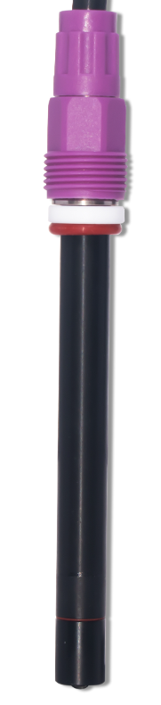

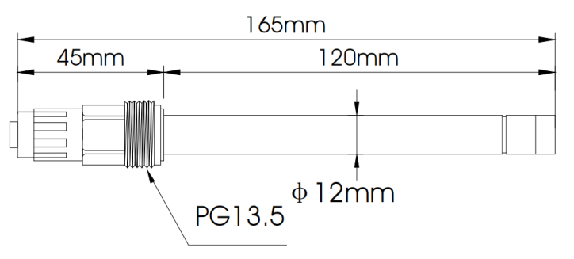

CS6520W-SE
Nitrate (nitrate ion) electrode

Specification parameters：
Type: PVC membrane ion-selective electrode
Range：0.4-62000mg/L
pH range：0-50℃
Pressure Resistance: Non-pressure-resistant
Temperature sensor：
Electrode mode: Single measurement electrode (requires reference electrode)
Shell material：PVC
Connecting thread：PG13.5
Cable length：5m or as agreed
Cable connector：S8 cable

Order number
Name | Content | Number
Temperature sensor | None | N0
Cable length(S8) | 5m | m5
Cable length(S8) | 10m | m10
Cable length(S8) | 15m | m15
Cable length(S8) | 20m | m20
Cable connector | Tinned | A1
Cable connector | Fork Terminal | A2
Cable connector | Straight Pin Header | A3
Cable connector | BNC | A4

