T9003
Total Nitrogen On-line Automatic Monitor

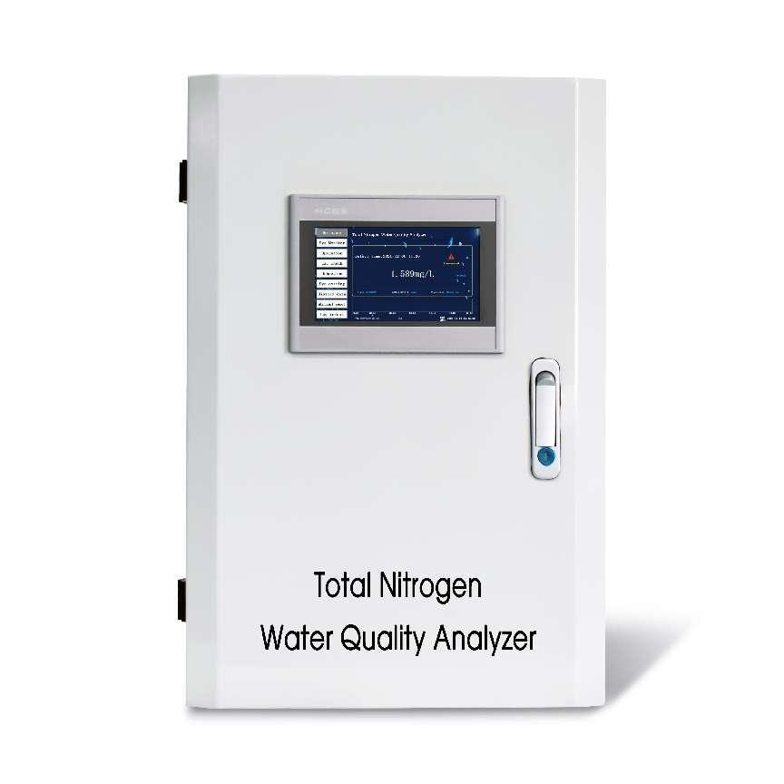

- Product Overview:
Total nitrogen in water mainly comes from decomposition products of nitrogen-containing organic matter in domestic sewage by microorganisms, industrial wastewater such as coking synthetic ammonia, and farmland drainage. When the total nitrogen content in water is high, it is toxic to fish and harmful to human beings in varying degrees. The determination of total nitrogen in water is helpful to evaluate the pollution and self-purification of water, so total nitrogen is an important indicator of water pollution.
The analyzer can work automatically and continuously for a long time without attendance according to the site settings. It is widely used in industrial pollution source discharge wastewater, municipal sewage treatment plant wastewater, environmental quality surface water and other occasions. According to the complexity of site test conditions, the corresponding pretreatment system can be selected to ensure the test process is reliable,test results are accurate, and fully meet the needs of different occasions.

- Product Principle:
After mixing water sample and masking agent,total nitrogen in the form of free ammonia or ammonium ion in alkaline environment and in the presence of sensitizing agent reacts with potassium persulfate reagent to form a colored complex.The analyzer detects the colour change and converts the change into ammonia nitrogen value and output it.The amount of coloured complex formed is equal to the amount of ammonia nitrogen.
This method is suitable for wastewater with total nitrogen in the range of 0-50mg/L. Excessive calcium and magnesium ions, residual chlorine or turbidity may interfere with the measurement.

- Technical Parameters:
No. | Name | Technical Parameters
1 | Range | Suitable for wastewater with total nitrogen in the range of 0-50mg/L.
2 | Test Methods | Spectrophotometric determination of potassium persulfate digestion
3 | Measuring range | 0~50mg/L
4 | Detection  Lower limit | 0.02
5 | Resolution | 0.01
6 | Accuracy | ±10% or ±0.2mg/L(take the larger value)）
7 | Repeatability | 5% or 0.2mg/L
8 | Zero Drift | ±3mg/L
9 | Span Drift | ±10%
10 | Measurement cycle | The minimum test cycle is 20 minutes. Color chromogenic time can be modified in 5-120min according to site environment.
11 | Sampling period | Time interval (adjustable), integral hour or trigger measurement mode can be set.
12 | Calibration cycle | Automatic calibration (1-99 days adjustable), according to actual water samples, manual calibration can be set.
13 | Maintenance cycle | Maintenance interval is more than one month, about 30 minutes each time.
14 | Human-machine operation | Touch screen display and instruction input.
15 | Self checking protection | Working status is self-diagnostic, abnormal or power failure will not lose data. Automatically eliminates residual reactants and resumes work after abnormal reset or power failure.
16 | Data storage | No less than half a year data storage
17 | Input interface | Switch quantity
18 | Output interface | Two RS232 digital output, One 4-20mA analog output
19 | Working Conditions | Working indoors; temperature 5-28℃; relative humidity≤90% (no condensation,no dew)
20 | Power Supply and Consumption | AC230±10%V, 50~60Hz, 5A
21 | Dimensions | 355× 400×600(mm)

