T9048 Multi-parameter Online Water Quality Monitor
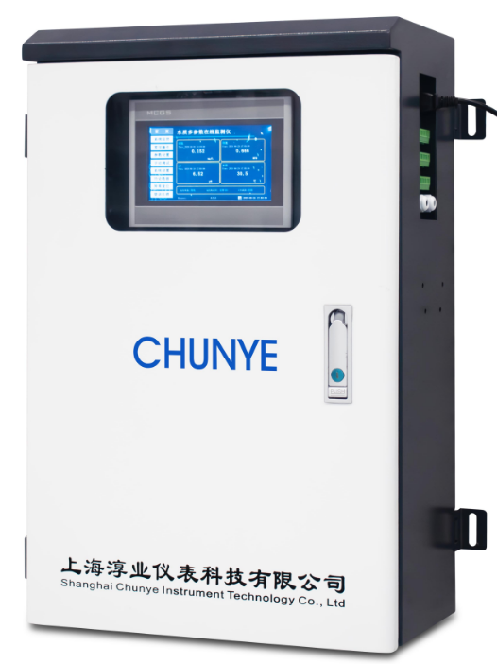

Typical Applications
For online monitoring of water supply outlet, pipeline water quality, secondary water supply in residential areas, and water treatment effluent.

Parameter range:
order | factor | measuring range | certainty of measurement
1 | pH | 0.01～14.00pH | ±0.05pH
2 | ORP | -1000～＋1000mV | ±3mV
3 | TDS | 0.01～2000mg/L | ±1%F.S
4 | conductivity | 0.01～200.0～2000μs/cm | ±1%F.S
5 | turbidity | 0.01～100.0NTU | ±1%F.S
6 | suspended matter | 0.01～200.0mg/L | ±1%F.S
7 | DPD residual chlorine | 0.01～5.00mg/L | ±1%F.S
8 | Total chlorine in DPD | 0.01～5.00mg/L | ±1%F.S
9 | temperature | 0.1～60.0℃ | ±0.3℃
10 | signal output | RS485 MODBUS RTU for Bus 1
11 | Control output | 3-channel relay output
12 | history | have
13 | Historical curve | have
14 | 4G long-distance transmission | Yes, optional
15 | way to install | Wall-mounted
16 | Water-like connection | Fast inlet/outlet card
17 | Water-like temperature | 5～40℃
18 | Water-like flow velocity | 200～600mL/min
19 | levels of protection | IP65
20 | Power Supply Voltage | 100～240VAC or 24VDC
21 | plant capacity | About 30W
22 | instruments weight | Approximately 35KG
23 | Instrument size | Height 700 mm * Width 450 mm * Depth 285 mm

